Infosys Springboard
kids’ screentime patterns to uncover using data Visualization
Problem Statement:
Analyse kids’ screentime patterns to uncover trends by age, gender, location type (urban/rural), device type, day-of-week, and activity category using data visualization. The goal is to present clear, actionable insights for parents, educators, and policymakers.

Load the dataset
Source: Kaggle — Indian Kids Screentime 2025 https://www.kaggle.com/datasets/ankushpanday2/indian-kids-screentime-2025
Preprocessed and Cleaned dataset:
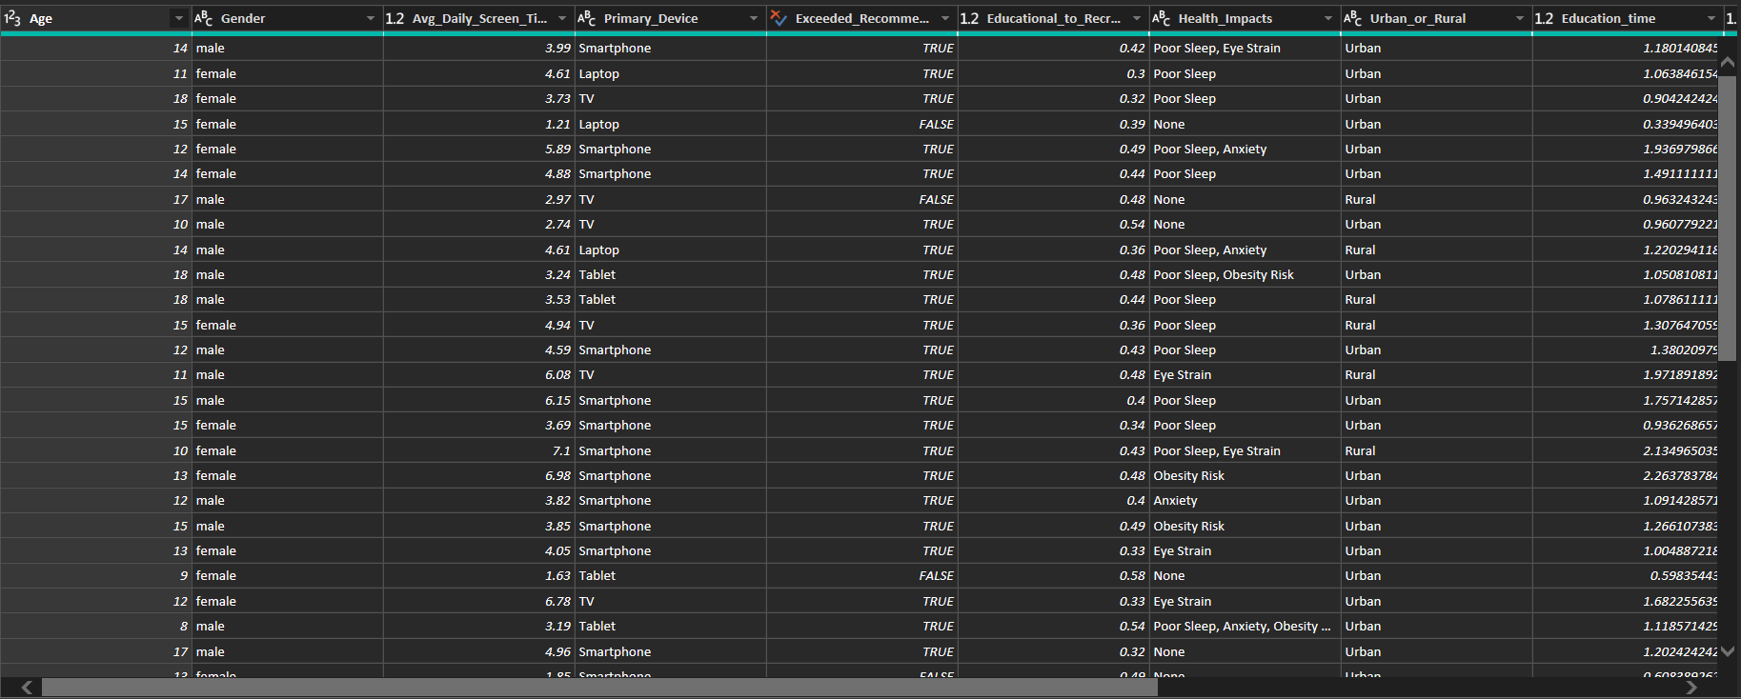

Introduction
This report presents a detailed analysis of screen time patterns, educational usage, recreational activities, and device preferences across different demographic groups. The insights are derived from an interactive Power BI dashboard consisting of 5 major pages:
Home, Policymakers, Educators, Parents, and Cohorts.
The objective of this study is to understand how screen time behaviours vary by age, gender, and location, and to identify key focus areas for decision-makers, educators, and parents.

Home Page Overview

The Home page acts as the entry point to the dashboard and provides a quick view of the most important indicators.
Key Features
- KPI Cards
  - Average number of Health impact an individual have
  - Percentage of Users Exceeding Recommended Screen Time Limit
  - Average Daily Screen Time
  - Education to Recreational ratio
  - Average Education Time
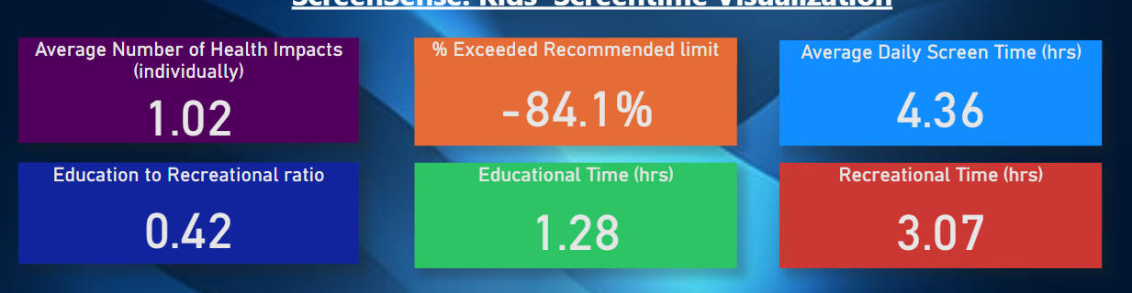
  - Average Recreation Time

- Slicers
  - Age Band
  - Gender
  - Location (Urban/Rural)
  - Primary Device
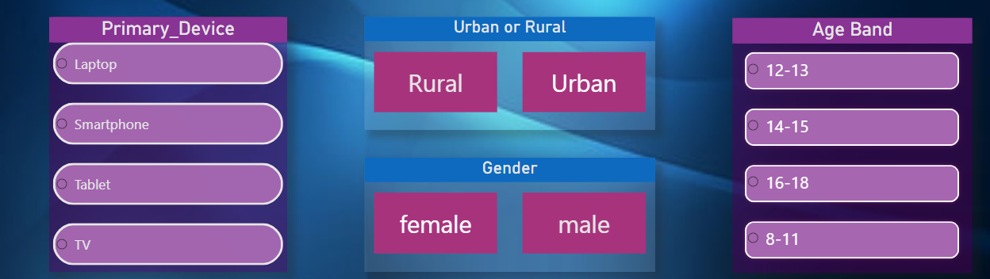

Insights
The overall KPIs help establish the baseline usage behaviour. The slicers allow users to dynamically filter the dataset and observe how screen time patterns shift across different demographic segments like gender, location, device, Age band.

policymakers Page

This page is designed to support government and policy-level decision-making by examining age-wise health impact and educational disparities.
Visuals Included

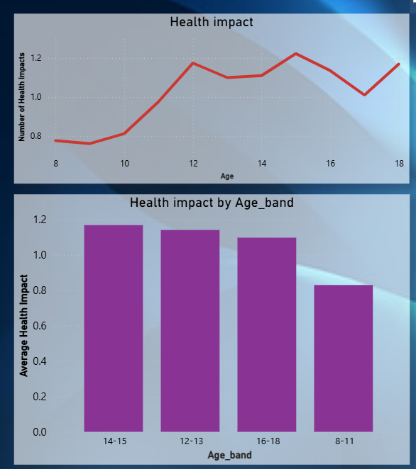
- Line Chart & Bar Chart – Number of Health Impacts vs Age

Shows how screen time correlates with self-reported or observed health impacts across age groups.
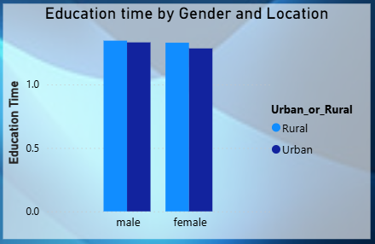
Bar Chart – Education Time vs Gender and Location

Compares educational screen usage among males and females, with a further split into urban and rural categories.

- Heatmap – Age Band vs Primary Device
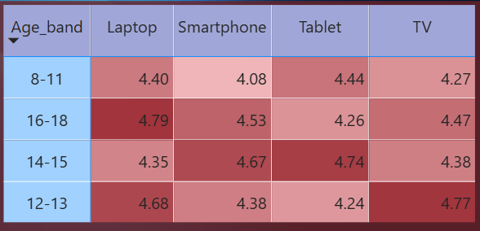

Displays device usage patterns (mobile, tablet, laptop, etc.) within different age bands.

Insights

Younger age groups tend to show higher usage of mobile devices. Health-related impacts increase with age or prolonged usage. There is very less difference (1-2%) in education time between urban and rural users, as well as between genders.

Educators Page
This page focuses on helping teachers and academic institutions understand how students allocate screen time to learning versus recreation.
Key Visuals
- Scatter Plot – Education to Recreation Ratio
Plots the balance between learning activities and leisure use of urban and rural location
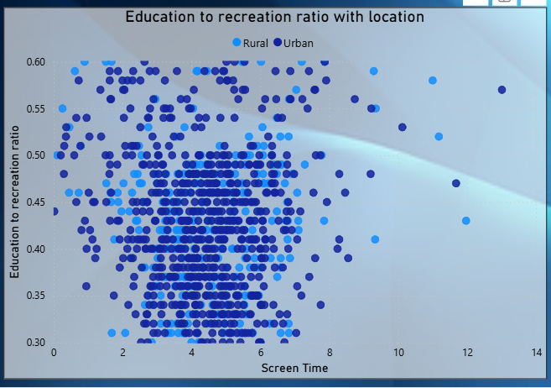
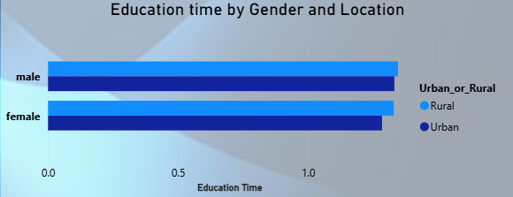
- Bar Chart – Education Time by Gender
Helps understand if one gender engages more in learning-related activities.
- Bar Chart – Education Time by Age Band with Primary Device
Shows how learning time varies across age categories and which device is preferred for studying.

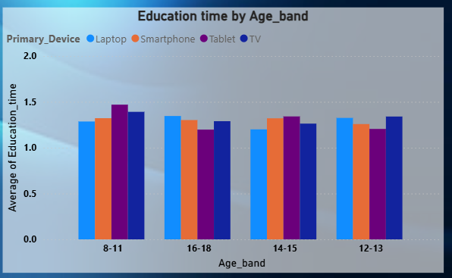

Insights
- The education-to-recreation ratio reveals whether time is being optimally spent.
- Device dependency for education shifts significantly across age groups.

Parents Page
This page provides insights targeted at parents, focusing on how children spend time across educational and recreational activities.

Visuals Included
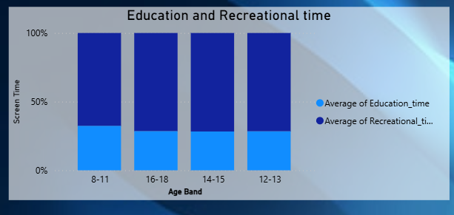
- Bar Chart – Education & Recreation Time vs Screen Time and Age Band
Shows how total screen time breaks down into productive (education) and non-productive (recreation) components.

- Donut Chart – Primary Device
Highlights which device children most frequently use.

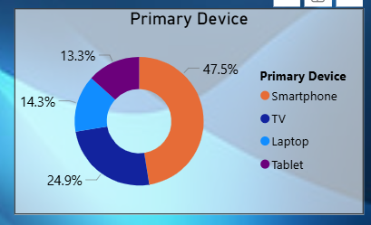

- Line Chart– Screen Time vs Age
Tracks how screen time increases or decreases with age.
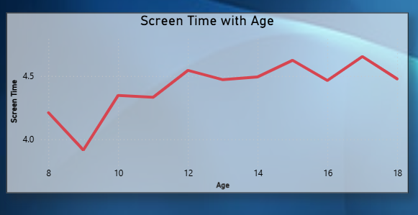
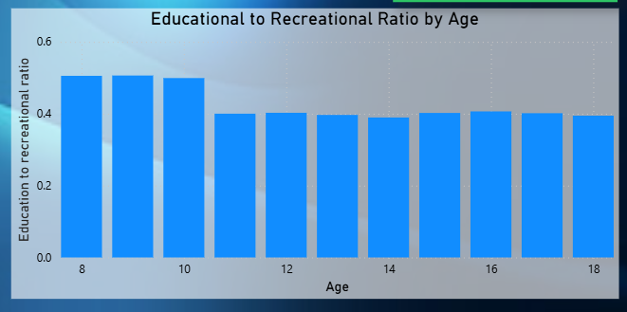
- Bar Chart – Education to Recreation Ratio vs Age
Indicates age groups that maintain healthy or unhealthy screen usage patterns.

Insights
- Parents can clearly see if children are spending excessive time on recreation compared to education. Age-based comparisons help identify critical stages where parental supervision is most needed.
- Device dependency is an important indicator of digital behaviour and potential risk levels.

Cohorts Page
This page allows comparison across segmented groups (cohorts) such as gender, location, and device usage.
Visuals Included
- Donut Chart – Primary Device Distribution
- Scatter Plot – Screen Time vs Age
- Bar Chart – Education to Recreation Ratio vs Age
- Slicers
  - Gender
  - Location (Urban/Rural)
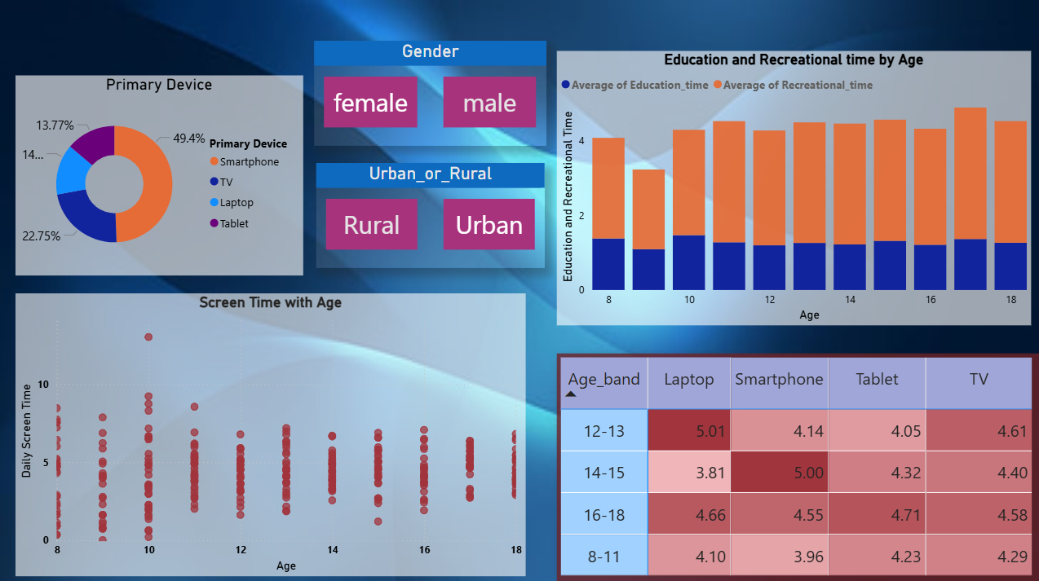

Insights
- Filtering by gender or location enables deeper behavioural comparisons.
- Primary device distribution indicates cohort-specific preferences.
- The education–recreation ratio helps determine whether a cohort is more academically inclined or entertainment-focused.

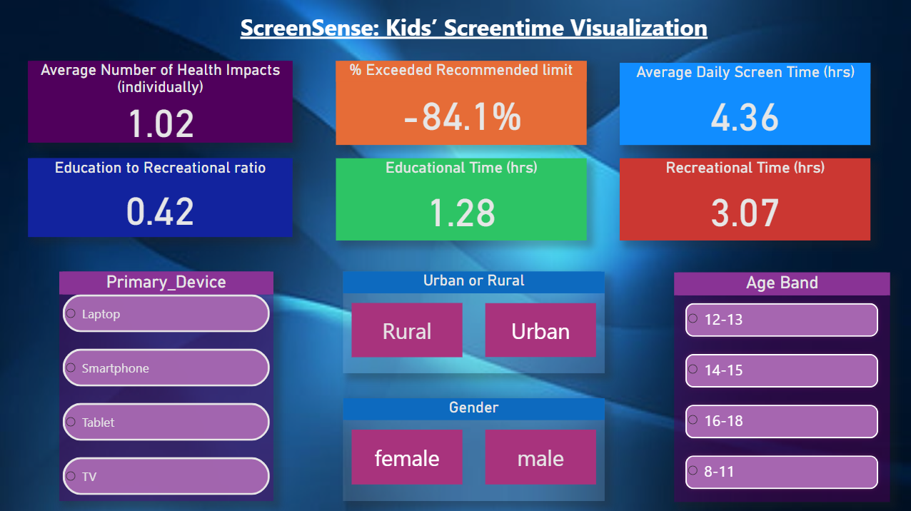
Page 1:

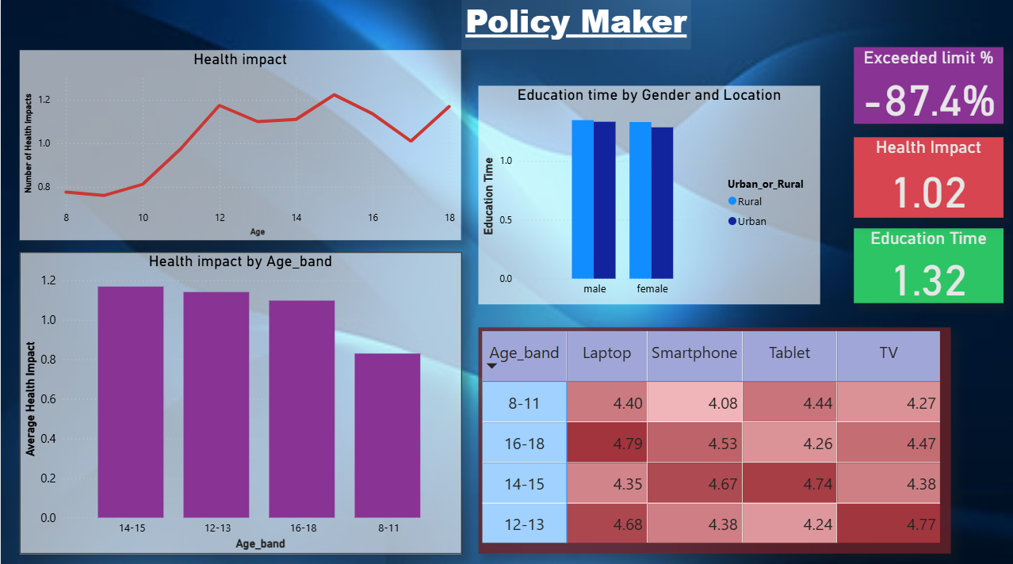
Page 2:
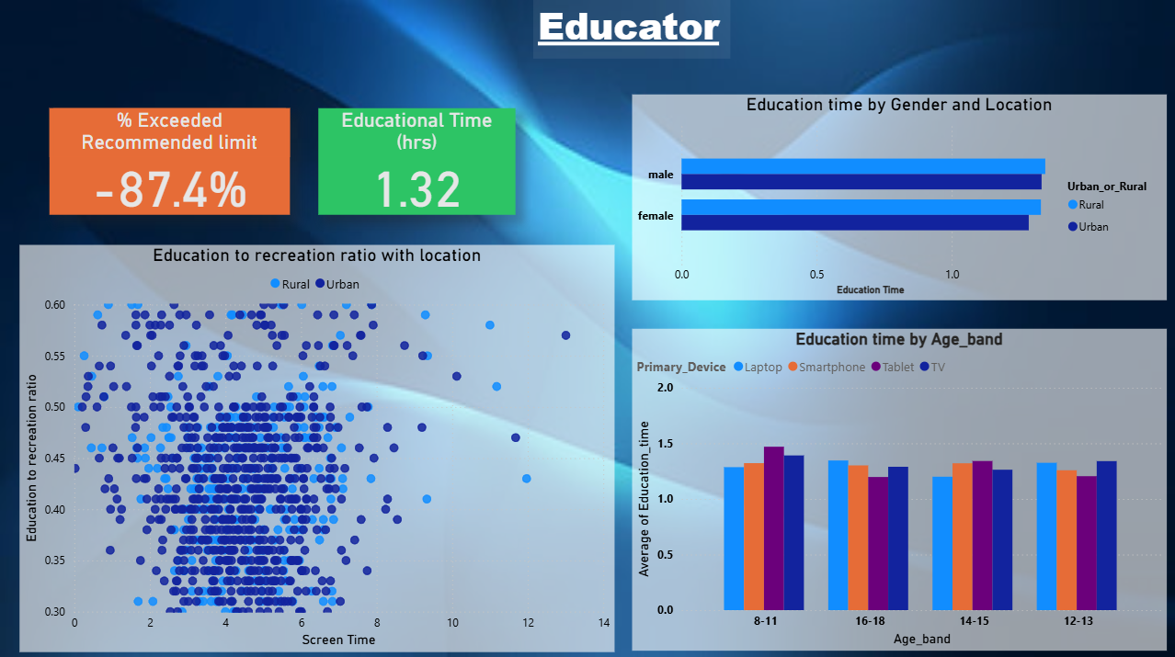
Page 3:

Page 4:
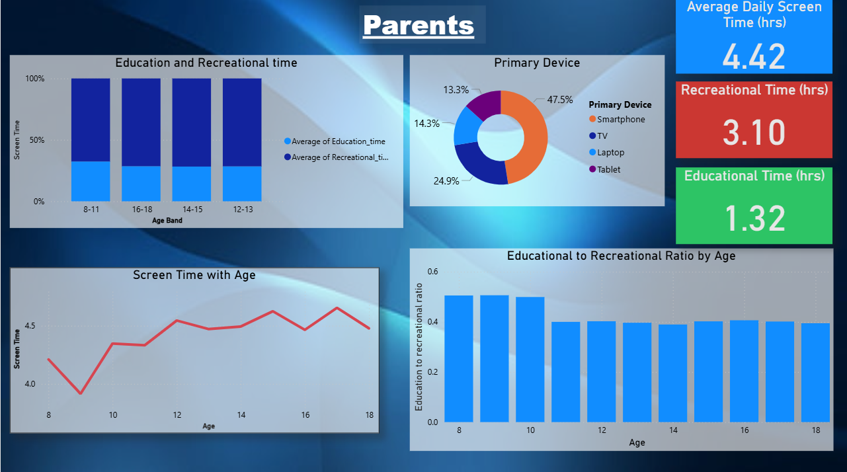

Conclusion
The Power BI dashboard provides a comprehensive view of digital usage behaviour across multiple demographic layers.
Insights from the four pages support:
- Policymakers in designing awareness and health programs.
- Educators in understanding and improving digital learning patterns.
- Parents in monitoring and guiding children’s screen habits.
- Analysts in identifying significant behavioural clusters through cohort comparisons.
Overall, the dashboard highlights critical patterns in screen time usage and offers a valuable tool for informed decision-making.

